FinalCW-COMP1787

Name: Trần Nguyễn Đông Quân  
Reg No: 001391506

Department: Computing  
Course Work Name & Course Code: COMP1787  
Submission Date: 15/04/2024

Email ID: [tq5929r@gre.ac.uk](mailto:tq5929r@gre.ac.uk)

**Table of content**

Contents

**Section – A (30 Marks)** 3

**A1** **Introduction about Online Green Groceries Platform** 3

**A2** **Drawbacks of Traditional Software Development Methodology** 4

**A3** **Agile Frameworks Methods and its Overview.** 5

**A4** **Systematic Workflow of Green Groceries Online Platform done with Agile Method** 6

**A5** **Summary:** 14

**Section – B (40 Marks)** 16

**B1** **Base line Requirement Review** 16

**B1.1** **Given Requirement Analysis using Moscow Rules (Table 1)** 16

**B1.2** **Updated High Level Functional Requirements (8 to 10 requirements)** 18

**B2** **Timebox Rules for the Updated High Level Functional Requirements:** 19

**B2.1** **Prioritization for the List of Requirements** 19

**B2.2** **Explanation about Prioritizing the Requirements and the Decisions taken for the Green Groceries Online Platform** 21

**Section – C (30 Marks)** 23

**C1** **Should Write Four parts in this section. (15 marks)** 23

**C1.a** **Legal issue explanation with one case study example** 23

**C1.b** **Social issue explanation with one case study example** 24

**C1.c** **Ethical issue explanation with one case study example** 25

**C1.d** **Professional issue explanation with one case study example** 26

**C2** **Discussion about the BCS code, and how the professionals following the practices of BCS code with their team members or co-workers. (15 marks)** 28

**C2.a** **Introduction about the Professional body of BCS code. (Can refer the website BCS. The Chartered Institute for IT I BCS** 28

**C2.b** **Public Interest — Practical example with explanation** 29

**C2.c** **Duty to Relevant Authority — Practical example with explanation** 29

**C2.d** **Duty to the Profession — Practical example with explanation** 29

**C3** **Conclusion and Assumption** 30

**References** 32

Figure 1: Roles Structure 6

Figure 2: Sprint 1 7

Figure 3: Sprint 2 8

Figure 4: Sprint 3 10

Figure 5: Sprint 4 12

Figure 6: Sprint 5 13

Figure 7: Time Box 22

**Requirement Management Report for the Case Study**

**“Green Groceries Online Platform”**

# **Section – A (30 Marks)**

## **Introduction about Online Green Groceries Platform**

* Online Green Grocery is a platform that enables clients to buy goods from the convenience of their own homes. It sells a variety of original and high-quality grocery items, such as grains, handmade spices, honey, nuts, seeds, oils, extracts, and more. The platform strives to provide clients with 100% real groceries.
* Customers may quickly traverse the website and discover the numerous categories and goods available thanks to its user-friendly layout. The portal also provides unique bundles and incentives, which allow users to save money on their purchases.
* Online Green Grocery is dedicated to offering the greatest customer experience possible and provides safe payment alternatives to ensure a smooth buying procedure. Customers may add things to their basket, inspect their cart, and then proceed to checkout when they are ready to make a purchase.
* The portal also offers essential tools like as professional culinary suggestions, which help clients make the most of their products and experiment with new dishes. Additionally, Online Green Grocery is active on social media sites such as Facebook, YouTube, and Instagram, allowing customers to remain up to speed on the newest goods, specials, and culinary ideas.

## **Drawbacks of Traditional Software Development Methodology**

* Traditional software development approaches, such as the Waterfall model, have various flaws that can affect both the development process and the end result. Some of the disadvantages include:
  + Traditional techniques use a sequential approach to development, with each step (requirements collection, design, coding, testing, etc.) completed before going on to the next. This rigidity may frequently cause delays and difficulty in responding to modified requirements or comments.
  + Traditional techniques have little flexibility when it comes to adopting modifications throughout the development process. When new needs or adjustments occur, it might be difficult to implement them without interrupting the overall operation.
  + Lack of consumer interaction: Traditional approaches frequently have minimal customer involvement, particularly in the early phases of development. As suggestions and comments are not continually incorporated throughout the process, there may be a disconnect between consumer expectations and the end result.
  + Longer development cycles: Traditional techniques' sequential structure allows for longer development cycles. Each phase must be finished before proceeding to the next, this can result in longer timelines for producing a workable product.
  + Limited openness and visibility: Traditional techniques may lack openness, creating it challenging for stakeholders to monitor project progress. This can cause confusion, delays in choices, and issues managing expectations.
  + Scope creep is more likely with traditional approaches due to limited client input and flexibility. Scope creep is the uncontrolled extension of project requirements, which causes delays, higher expenses and possible quality difficulties.
  + Limited adaptability to shifting market demands: In today's rapid marketplace, goals and objectives can shift quickly. Traditional approaches might be unable with adjusting to these changes, producing goods that may not satisfy current market expectations.

## **Agile Frameworks Methods and its Overview.**

* Rapid Application Development (RAD) is an agile technique which concentrates on rapid prototyping and software delivery. It requires iterative development, strong collaboration among stakeholders, and the usage of recyclable parts and technologies.
* Prototyping is a method applied to agile development to produce a functional model of software. It assists in visualizing the ultimate product, gathering input, and making required changes before real creation begins. Prototyping enables early user input and verification of design decisions.
* The timebox approach is an agile technique that includes assigning specified time boundaries to development phases or iterations. This keeps teams organized and makes sure the project moves forward in an organized way. Each timebox usually contains planning, development, testing, and review tasks.
* JAD (Joint Application Development) is an agile technique that promotes cooperation among developers, stakeholders, and users. It entails workshops and discussions in which all stakeholders actively contribute to requirement collection, concept sessions, and making choices. JAD encourages a shared knowledge of the project's objectives and facilitates successful communication.
* Sprints and Scrums: Sprints and Scrums are essential components of the Scrum framework, a popular agile approach. Sprints are time-limited iterations that typically run 1-4 weeks and involve the development, testing, and delivery of a defined set of features. Scrums are regularly held throughout a sprint to assess progress, plan future work, and handle any issues.
* DSDM (Dynamic Systems Development Method) is an agile methodology for developing functional software progressively and collaboratively. It focuses on constant user participation, continuous improvement, and the regular supply of business value. DSDM offers rules and guidelines for project management, solution development, and teamwork.
* Facilitated workshops are a method used in agile development to gather along stakeholders, programmers, and users. These workshops are organized meetings designed to collect needs, explore solutions, make choices, and promote teamwork. Facilitated workshops draw on the knowledge and viewpoints of all participants to establish a common understanding and alignment

## **Systematic Workflow of Green Groceries Online Platform done with Agile Method**

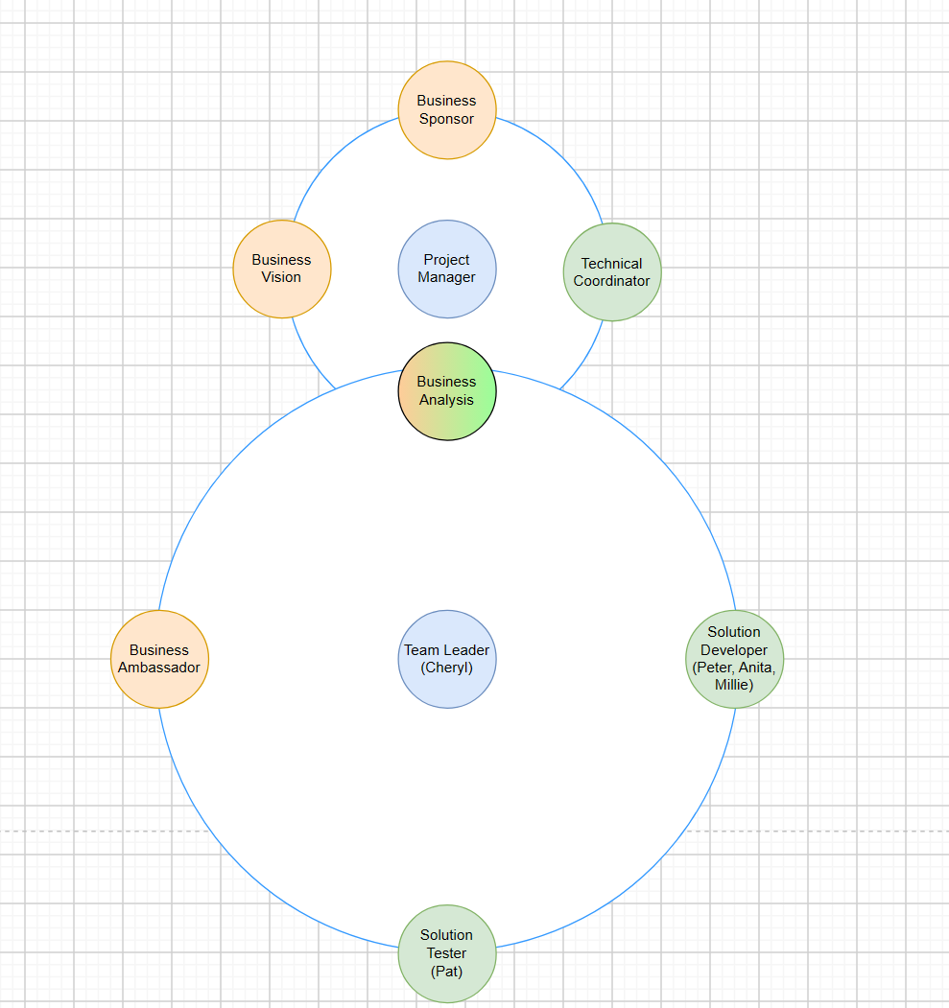

Figure 1: Roles Structure

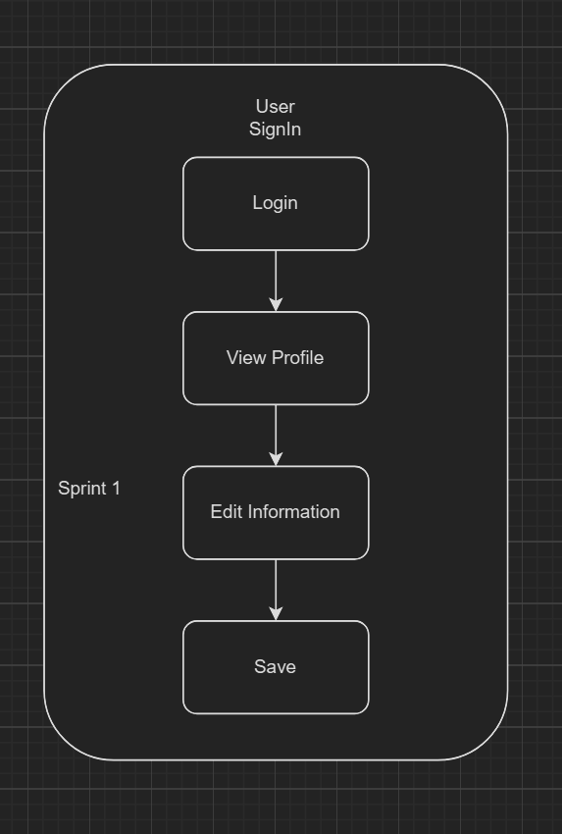

Figure 2: Sprint 1

* Week 1: Core Function
* Members:
  + Product Owner: Sarah
  + Scrum Master: Michael
  + Development Team: Peter (Lead Developer), Anita (Developer), David (Tester)
* Agenda:
  + Introduction and Goals
    - Give a brief overview of the Green Groceries project's goals.
    - Talk about the particular objectives for the first sprint, which include developing essential features like the Sign in, product browsing…
  + User Story
    - Describe user stories that pertain to the essential features (such as the ability to peruse sign in, Search good).
    - Assign the development team members duties and responsibilities for every user story.
  + Planning
    - Talk about the interdependence and possible difficulties pertaining to the essential functions.
    - Create a weekly communication schedule, including daily stand-up meetings and routes of communication.
    - Respond to any queries or worries raised by the group.
  + Action
    - The sprint backlog, action items, and important decisions are summed up by Michael (the scrum master).
    - The team defines each person's weekly tasks.

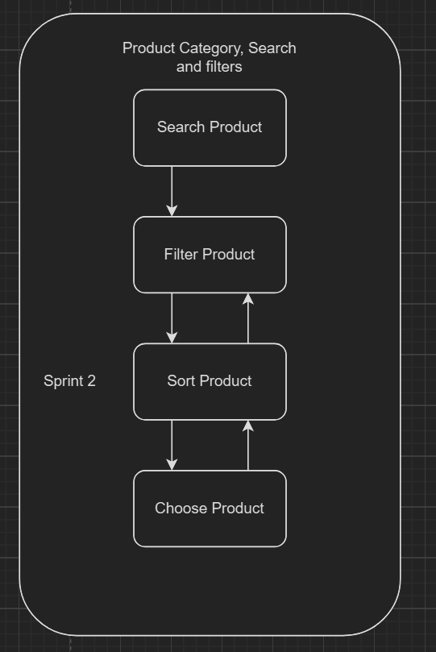

Figure 3: Sprint 2

* Week 2: Checkout and Order
* Members:
  + Product Owner: Sarah
  + Scrum Master: Michael
  + Development Team: Peter (Lead Developer), Anita (Developer), David (Tester)
* Agenda:
  + Week 1 Review
    - Examine the Week 1 user stories that have been finished (such as product browsing and adding to cart).
    - Talk about any obstacles or difficulties you had in Week 1.
  + Week 2 Planning
    - Putting in place product search features.
    - Dissect user stories pertaining to search (e.g., User may filter items by category; User may look for products by name).
    - Assign duties and obligations to every user narrative.
  + Discussion
    - Talk about the features and design of the search interface.
    - Think about the choices available for product filtering (e.g., by category, cost range, branding).
    - Respond to any queries or worries raised by the group.
  + Action
    - Provide a summary of the week two's major choices, tasks, and sprint backlog.
    - Make each person's weekly tasks clear.

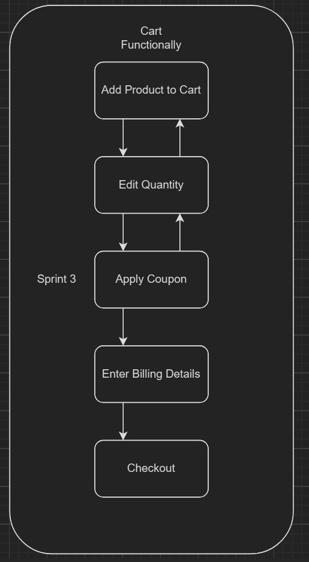

Figure 4: Sprint 3

* Week 3: User Account Management
* Members:
  + Product Owner: Sarah
  + Scrum Master: Michael
  + Development Team: Peter (Lead Developer), Anita (Developer), David (Tester)
* Agenda:
  + Week 2 Review
    - Examine the Week 2 user stories that have been finished.
    - Talk about any obstacles or difficulties you have this week.
  + Week 3 Planning
    - Creating functions for user registration and login, along with tools for managing user profiles.
    - Break out user stories that pertain to user accounts (e.g., "User can manage account details," "User may sign up for an account").
    - Assign duties and obligations to every user narrative.
  + Discussion
    - Talk about the functionality and design of the user signup and login procedure.
    - Think about the user profile management choices.
    - Respond to any queries or worries raised by the group.
  + Action
    - Provide a summary of the week three's major choices, action items, including sprint backlog.
    - Make each person's weekly tasks clear.

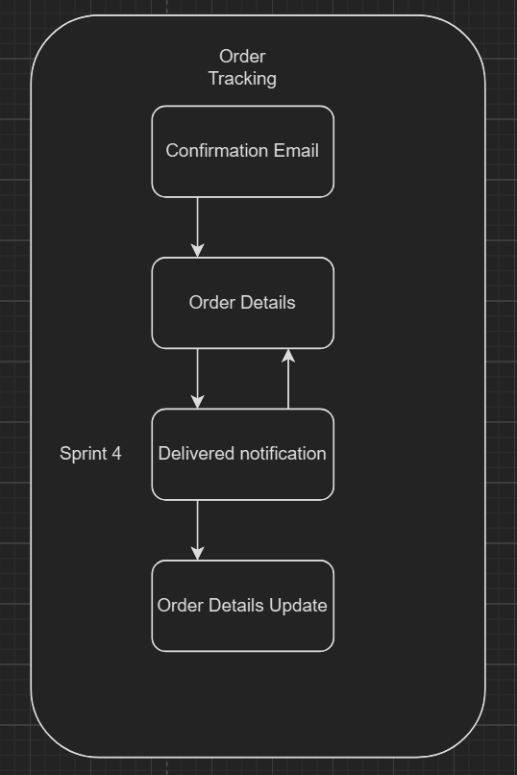

Figure 5: Sprint 4

* Week 4: Order Tracking
* Members:
  + Product Owner: Sarah
  + Scrum Master: Michael
  + Development Team: Peter (Lead Developer), Anita (Developer), David (Tester)
* Agenda:
  + Week 3 Review
    - Examine the Week 3 user stories that have been finished.
    - Talk about any obstacles or difficulties you ran into in Week 3.
  + Week 4 Planning
    - Establish the objectives for Week 4: putting order tracking features into place.
    - Describe each of the order tracking user stories in detail (e.g., User can check the history of an order, User may monitor order progress).
    - Assign duties and obligations to every user narrative.
  + Discussion
    - Talk about the functionality and design of the order tracking interface.
    - If applicable, take into account integrating with any purchase delivery systems or logistical companies.
    - Respond to any queries or worries raised by the group.
  + Action
    - List the main choices, actions, and sprint backlog for the fourth week.
    - Make each person's weekly tasks clear.

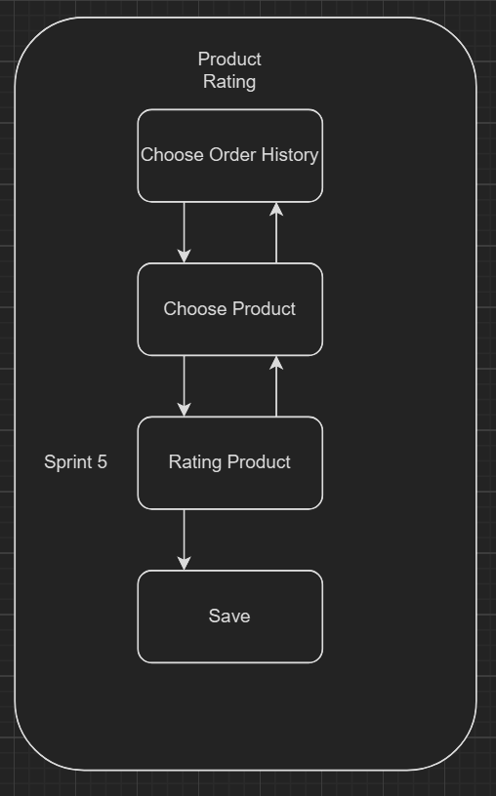

Figure 6: Sprint 5

* Week 5: Product Rating
* Members:
  + Product Owner: Sarah
  + Scrum Master: Michael
  + Development Team: Peter (Lead Developer), Anita (Developer), David (Tester)
* Agenda
  + Week 4 Review
    - Examine the Week 4 user stories that have been finished (such as the order tracking features).
    - Talk about any obstacles or difficulties you ran into in Week 4.
  + Week 5 Planning
    - Establish the objectives for Week 5: putting in place features for product ratings.
    - Dissect user stories that have to do with rating products (e.g., User can browse product reviews, User may provide a rating for a product).
    - Assign duties and obligations to every user narrative.
  + Discussion
    - Talk about the features and design of the system for reviewing and rating products.
    - Think about the user experience for showing reviews and the moderation procedures.
    - Respond to any queries or worries raised by the group.
  + Action
    - Provide a synopsis of Week 5's major choices, tasks and backlog.

## **Summary:**

* Sprint Structure:
  + Every week has a similar structure:
  + Review: The team goes over the previous week's finished user stories and talks about any barriers or issues they experienced.
  + Planning: The emphasis for the following week is determined, including particular user stories relating to the anticipated functionality. Team members are allocated duties for each user narrative.
  + The team discusses the functions and the layout of the functionality being built during the current sprint. This includes conversations regarding the user experience, available alternatives, and possible interaction with external systems.
  + Action: This week's major choices, tasks, and sprint backlog are summarized. Individual team members' duties are specified.
* Sprint Focus by Week:
  + Week 1: Overview and Core Functions: Sign in, browse products, and add to cart.
  + Week 2: Checkout and Order - Adding functionality for checkout and order placing.
  + Week 3: User Account Management - Implementing user registration, login, and profile management functions.
  + Week 4: Order Tracking - Creating functionality to track the order's state and history.
  + Week 5: Product Rating - Setting up features for evaluations and ratings.

1. **Merits of Using Agile Concepts (5 to 7 points is enough)**

* Conventional software development approaches frequently have low user interaction and are rigid. Similar to the Waterfall model, these techniques follow a strict, sequential process in which every stage (requirements collection, design, coding, and testing) must be finished before going on to the next.
* Delays and trouble adjusting to shifting requirements or feedback may result from this. Furthermore, conventional approaches frequently distance themselves from their clients, especially in the beginning phases of growth. This may lead to a finished product that falls short of user expectations.
* Agile development presents a novel substitute. Here, adaptability and teamwork are paramount. Iterative development cycles and quick prototyping are prioritized by methodologies such as quick Application Development (RAD). Early user input and faster product delivery are made possible by this. Moreover, agile techniques divide projects into shorter, time-limited iterations known as sprints. Teams remain concentrated and make consistent progress as a result. Stakeholders, developers, and users collaborate closely throughout these sprints.
* Joint Application Development (JAD) workshops and assisted meetings are examples of practices that guarantee everyone is in agreement and encourage candid communication. This constant cooperation makes it easier to find and fix problems early, which results in software that is of higher quality.
* Agile development's emphasis on ongoing feedback and improvement is one of its main advantages. With the use of prototypes, developers may get early user feedback and solve any issues before allocating substantial resources. Short periods of development with integrated testing phases also guarantee prompt detection and correction of errors.
* Agile projects can adjust to shifting market demands and produce software that is useful and relevant to consumers thanks to this iterative methodology.

# **Section – B (40 Marks)**

## **Base line Requirement Review**

### **Given Requirement Analysis using Moscow Rules (Table 1)**

|  |  |  |  |
| --- | --- | --- | --- |
| **ID** | **Requirement List** | **Moscow Rule** | **Reasons** |
| 1 | As an Order Handling Clerk, I want to use the website to process telephone purchases, replacing the paper-based system. | Must Have | Eliminates inefficient paper-based system.  Improves order processing efficiency. |
| 2 | Maintain at least 20 office plants as part of the company's commitment to a green and healthy workspace. | Could Have | Improves work environment but not critical for website functionality.  May require separate budgeting and implementation. |
| 3 | As a customer, I want to be able to change my account details to ensure my most up-to-date information is recorded. | Must Have | Enables customer self-service for account management.  Improves data accuracy. |
| 4 | Organize a virtual celebration on the website for the CEO's birthday to showcase the company's fun and friendly culture. | Could Have | Focuses on internal celebration, not core website functionality.  Can be implemented later or through other means. |
| 5 | As the Managing Director I want to be ensured that the site is Data Protection Act safe so that we do not get fined hundreds of thousands of pounds. | Must Have | Legal compliance to avoid hefty fines.  Protects customer data privacy. |
| 6 | As a customer register an account. | Must Have | Essential for customer identification and order processing. - Enables personalized shopping experience. |
| 7 | As a Customer I want a choice of delivery slots so that I can arrange my diary appropriately. | Should Have | Improves customer experience and convenience.  May increase customer satisfaction and potentially sales. |
| 8 | As a customer, I want to be able to modify my shopping cart so that I can change my mind about what I want to buy. | Must Have | Essential feature for user control and flexibility during checkout.  Reduces cart abandonment. |
| 9 | The company should adopt pet-friendly policies to create a positive and inclusive work environment. | Could Have | Focuses on company policy, not website functionality.  Can be a separate initiative. |
| 10 | The system must be designed to handle a 30% increase in traffic during peak periods without degradation in performance. | Should Have | Ensures website scalability and avoids performance issues during peak times.  Improves user experience and brand reputation. |
| 11 | As a customer, I want to enter separate delivery and invoice addresses so that I can receive bags when staying at a friend's house. | Should Have | Improves customer experience and order flexibility.  May increase customer satisfaction. |
| 12 | As a Customer I want to be able to change my account details so that my most up to date details are recorded. | Must Have | For convenience, security, and correct orders, customers must update their information. |
| 13 | As an Order Handling Clerk I want to use the Web site to process telephone purchases so that I can stop using the paper-based system. | Should Have | For data management, cost savings, and efficiency, clerks require online phone order processing. |
| 14 | As a customer, I want to choose whether or not I am sent marketing information to avoid receiving excessive junk mail. | Should Have | Enhances customer control over their data and preferences. Improves customer experience and potentially reduces unsubscribes. |
| 15 | All user data, including personal information and payment details, must be encrypted to ensure the highest level of security. | Must Have | Essential for data security and customer trust.  Protects against data breaches and legal issues. |
| 16 | Maintain consistent branding elements and design across the website to reinforce their brand identity. | Should Have | Creates a professional and recognizable user experience. Improves brand image and customer perception. |
| 17 | The development team should participate in a team-building event every quarter to foster collaboration and a positive work environment. | Could Have | Focuses on internal team development, not website functionality.  Can be a separate initiative. |
| 18 | As the Marketing Director I would like an offers or discount page so that we can inform our customers of the aforementioned. | Should Have | Important marketing tool for customer engagement and sales promotion.  Can be implemented later if time allows. |
| 19 | As the Chief Accountant I want to the Web site to adhere to legislation regarding VAT so we are not hit with a hefty fine. | Must Have | Legal compliance to avoid financial penalties.  Ensures accurate tax calculations. |
| 20 | As the Operations Director, I want to accept all forms of payment to capture the largest market possible. | Should Have | Improves customer convenience and caters to various payment preferences. May increase sales and customer satisfaction. |

### **Updated High Level Functional Requirements (8 to 10 requirements)**

|  |  |  |  |
| --- | --- | --- | --- |
| **ID** | **High Level Functional Requirements** | **Moscow rules** | **Justifications / Recommendation** |
| **1** | Product Details | Must Have | Allow User to views more details about the chosen product |
| **2** | Product Category, Search and filters | Must Have | Allows for simple browsing and discovering certain goods |
| **3** | Order Tracker | Must Have | Allow users to acknowledge information about the status of their orders and promotes being transparent |
| **4** | Product Rating | Should Have | motivates communication and supports customers in making choices that are right |
| **5** | Order History and re-order | Should Have | Makes it easier to repurchase things that are frequently ordered |
| **6** | Payments | Must Have | Secure transactions via many kinds of ways, such as online banking, debit cards, and credit or PayPal |
| **7** | Real-time management of stocks shows current product supply to prevent shipment difficulties | Must Have | improves the user's experience by keeping not in stock transactions at distant and notifying users to goods that are in stock |
| **8** | Product Coupon on Special Event | Could Have | Give user discount on holiday for boosting interest |

## **Timebox Rules for the Updated High Level Functional Requirements:**

### **Prioritization for the List of Requirements**

|  |  |  |  |
| --- | --- | --- | --- |
| **ID** | **Updated High Level Functional Requirements** | **Priority Levels (High or Moderate or Low)** | **Time Scale** |
| **1** | Product Details | **High**  **(Development Team)** | **1 days** |
| **2** | Product Category, Search and filters | **High**  **(Development Team)** | **3 days** |
| **3** | Order Tracker | **High**  **(Logistics Team)** | **5 days** |
| **4** | Product Rating | **High**  **(Marketing Manager)** | **1 days** |
| **5** | Payments | **High**  **(Development & Chief Accountant)** | **2 days** |
| **6** | Real-time management of stocks shows current product supply to prevent shipment difficulties | **High**  **(Logistic Manager)** | **5 days** |
| **7** | Order History and re-order | **Moderate**  **(Development Team)** | **3 days** |
| **8** | Product Coupon on Special Event | **Low**  **(Development Team & Marketing Manager)** | **2 days** |

### **Explanation about Prioritizing the Requirements and the Decisions taken for the Green Groceries Online Platform**

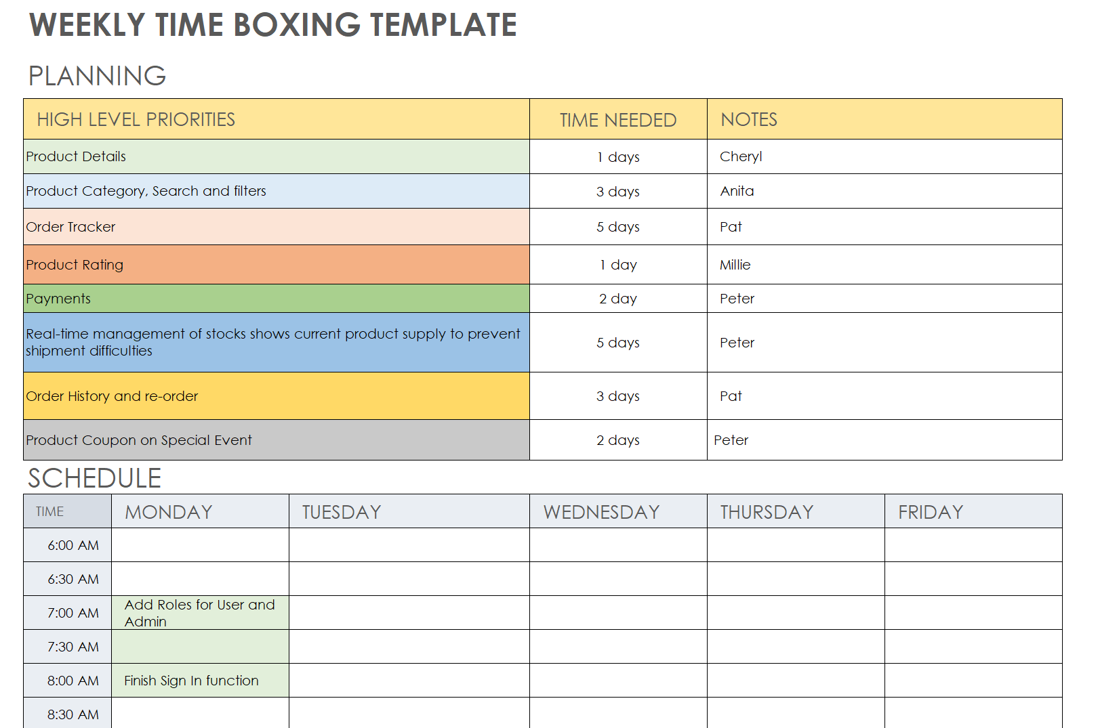

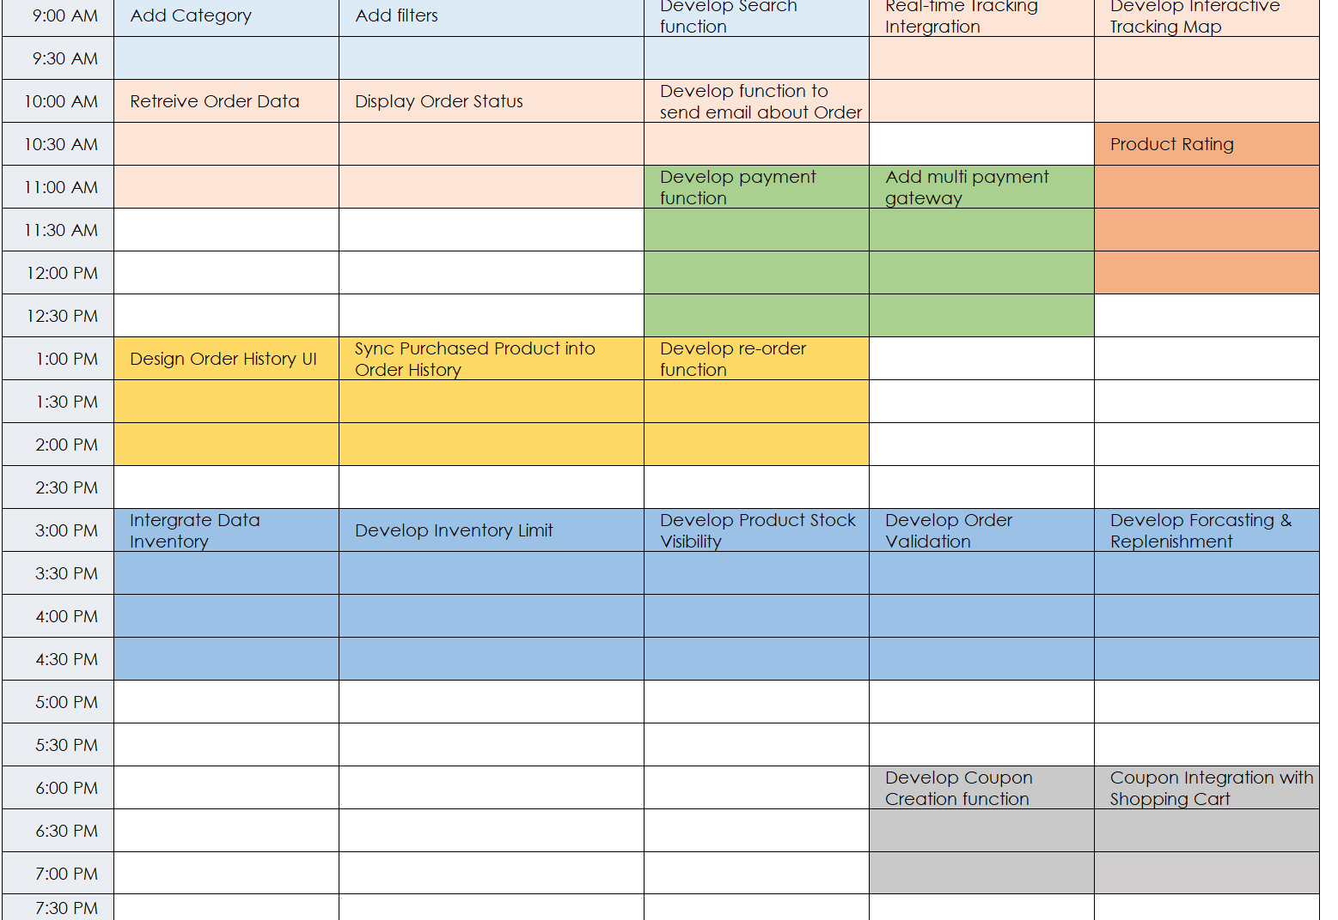

Figure 7: Time Box

* Product Details: (High Priority)
  + - Users are able to view more details about the product
    - Product details is high priority due to help User to look at specific information such as ingredient, brand, …
* Product Category, Search and filters: (High Priority)
  + Users can quickly locate the things they're seeking for thanks to this high priority feature:
    - Better user experience: People can locate what they're looking for with ease and speed.
    - Increased sales: When consumers can readily locate the things they desire, they are likely to make a purchase.
    - Decreased bounce rate: If a user is irritated and can't find what they're searching for, they are less likely to abandon the website.
* Order Tracker: (High Priority)
  + Users are able to monitor the progress of their orders with this high priority service.
  + Better customer experience: By allowing users to track the status of their orders during the fulfillment process, questions and concerns are decreased.
  + Less effort for customer care representatives: If customers can simply follow their orders online, they might be less inclined to call customer service to find out how their orders are doing.
* Product Rating: (Moderate Priority)
  + Users are able to evaluate and rate items using this medium priority feature.
  + Better user experience: Based on previous customers' reviews, users may make well-informed judgments.
  + Increased sales: Trust-building and purchase encouragement are two benefits of positive ratings.
* Payments: (High Priority)
  + The safe payment of orders is made possible by this high priority function for users. For any kind of online store to work, this is necessary. It would not be possible for users to finish their purchases without a payment mechanism.
* Real-time management of stocks shows current product supply to prevent shipment difficulties: (High Priority)
  + Ensuring that consumers are only ordering things that are in stock is made easier with this high priority feature.
  + Better customer services: Order cancellations resulting from out-of-stock merchandise are less common.
  + Sale growth: If customers are certain that the products are in stock, they could place an order more frequently.
  + Lower costs: Accurate inventory data on the platform helps minimize fulfillment mistakes and related expenses (such refunds and reshipping).
* Order History and re-order: (Moderate Priority)
  + Users may simply rearrange things and check their previous order history using this feature, which has a moderate priority.
  + Better user interaction: It's quick and simple for users to repurchase regularly purchased goods.
  + Improved profits: This characteristic may promote recurring business.
* Coupon (Low Priority)
  + Using Coupon for boosting user’s interest
  + Coupon also help Green Groceries’ inventory can be sold faster.

# **Section – C (30 Marks)**

## **Should Write Four parts in this section. (15 marks)**

### **Legal issue explanation with one case study example**

* Definition
  + A legal issue occurs when a circumstance necessitates the use of the law to address a disagreement or difficulty. It's fundamentally an issue of what the law implies in a certain situation and how it must be implemented. This sometimes entails disagreements among individuals, and legal experts utilize their skills to clarify the law and advocate for its implementation in a way that favors their client. The ultimate objective is to get a legal conclusion.
* Example from Green Groceries Case study:
  + Green Groceries encourages the sale of a range of fruits and vegetables that are "certified organic." However, a consumer finds irregularities. Some "organic" products lack the recognized Bangladeshi organic label sticker, raising questions about the veracity of Green Grocer's claims.
  + Misrepresentation: Advertising and selling products as "organic" without sufficient certification may be deemed fraudulent marketing under Bangladeshi laws protecting consumers. Consumers want "organic" to refer to items cultivated in accordance with strict laws.
  + Organic Certification: Bangladesh is likely to have legislation that define organic food and need certification from a recognized authority. Green Groceries must demonstrate that they have secured the relevant certifications for items marketed as organic.
* Example 2 Use-case: Uber vs. California (2020)
  + Uber, a ride-sharing corporation, classifies its drivers as self-employed freelancers rather than employees. This meant that Uber was not required to give perks such as wages or insurance. California enacted legislation forcing app-based transportation businesses to designate drivers as workers.
  + The major legal question was if the Uber drivers were properly designated as freelancers under California regulations. This depended on the legal meaning of a worker and Uber's amount of control over its drivers.

### **Social issue explanation with one case study example**

* Definition
  + A social issue is an issue that has a substantial influence on a whole community or society. These difficulties are frequently complicated and multidimensional, with few straightforward answers. They can result from a variety of interconnected issues within a community, such as economic inequality, instability in politics, or religious disputes.
* Example from Green Groceries Case study:
  + Green Groceries, an online supermarket in Bangladesh, provides clients with a simple option to purchase fresh vegetables and groceries. However, their business approach may unintentionally contribute to a societal concern.
  + Concerns about accessibility: Because Green Groceries runs mostly online, persons without dependable internet connection or digital literacy may be unable to participate. This may worsen food insecurity among low-income communities who rely on physical grocery shops or local markets.
  + Inequality Availability to Healthy Food: If Green Groceries remains the main grocery choice in some locations, it may result in a food desert for those who are unable to use their online platform. This would restrict people's access to nutritious and fresh food alternatives, thereby contributing to health inequities.
* Use-case: E-waste
  + The booming popularity of electronic devices has resulted in a burgeoning e-waste crisis, where improper disposal in developing countries leads to toxic contamination of soil and water, posing health risks and exploiting child labor in the process, necessitating responsible disposal methods, robust recycling initiatives, and the design of products with longer lifespans and easier repairability.

### **Ethical issue explanation with one case study example**

* Definition
  + An ethical issue is a scenario that requires a tough judgment because it contradicts our perceptions of what is appropriate and unacceptable. These difficulties entail opposing moral principles, and there is no simple solution. We must analyze choices and negotiate zones of uncertainty to make the best ethical decision depending on our individual moral compass.
* Example from Green Groceries Case study:
  + Ethical Labor Methods: Green Groceries must guarantee that its suppliers treat employees properly. This involves paying fair salaries, maintaining secure workplaces, and preventing labor exploitation, especially in agriculture.
  + Green Groceries may face a problem. Sourcing products at the most affordable rates may jeopardize fair labor standards for farmers and laborers in agriculture.
  + Unethical Labor Methods: If Green Groceries stresses low costs and fails to thoroughly examine its suppliers, they may inadvertently encourage unjust labor standards such as low salaries, overtime, or unhealthy working conditions across the supply chain.
* Use-case: Global Water crisis
  + Exposure to clean waters is an essential human right, nevertheless thousands of people worldwide lack this basic need. This shortage generates a complicated societal problem with far-reaching effects.
  + The water problem impacts many facets of life, including:
    - Health: Waterborne infections produced by polluted water pose a significant health risk, especially for children.
    - Education: Lack of accessibility to clean water for personal hygiene and sanitation might impede student attendance and study.
    - Poverty: The effort and resources spent obtaining water can keep households trapped in poverty cycles. Women and girls frequently suffer the burden of water collection, which limits their possibilities for education and employment.
    - Gender Inequality: Women and girls have a disproportionate share of the duty of collecting water, restricting their education and possibilities.

### **Professional issue explanation with one case study example**

* Definition
  + A professional issue develops when a scenario requires a tough decision within the ethical standards of a certain profession. Conflicts can arise between a professional's commitments to customers, bosses, or the field as a whole. The law and ethical norms may not always agree, and competing interests in a professional context might exacerbate the dilemma. Finally, managing these problems demands good judgment and a dedication to ethical decision-making in order to maintain the profession's credibility.
* Example from Green Groceries Case study:
  + Privacy and Security Issues: Green Groceries must emphasize consumer information security and meet with Bangladesh's data protection legislation.
  + Green Grocery has a professional quandary. While gathering consumer data may be useful for marketing and customization, companies must do it responsibly and with sufficient customer consent.
  + If Green Groceries suffers a loss of data, customer data may be compromised, resulting in fraud and other security problems.
  + Customers who believe that the security of their information is not maintained may opt to leave Green Groceries, affecting their business.
  + Failure to keep up with privacy laws may result in penalties and taxes from regulatory bodies.
* Use-case: The Effects of Social Networking on Mental State
  + The advent of social media platforms such as Facebook, Instagram, and YouTube transformed communication and entertainment. However, there are rising worries about social media's deleterious influence on mental health, especially among young adults.
  + Compared and Social Stress: social media provides frequently depict idealized representations of people's lives, instilling feelings of insufficiency or social stress in users who relate themselves to these false depictions.
  + Cyberbullying and Abuse: The privacy and ease of communication available online can encourage cyberbullying and harassment, resulting in a hostile atmosphere for some users.
  + Addiction and Spotlight Need: The steady flood of alerts, likes, and comments may become addicting, instilling a desire for validation and changing dopamine reward systems, especially in younger users.
  + Sleep Deprivation: Midnight social media usage disturbs sleep patterns, lowering mood, focus, and general health.

## **Discussion about the BCS code, and how the professionals following the practices of BCS code with their team members or co-workers. (15 marks)**

### **Introduction about the Professional body of BCS code. (Can refer the website BCS. The Chartered Institute for IT I BCS**

* Introduction:
  + The Chartered Institute for IT (BCS) is the UK's premier organization for information technology (IT) professionals. Founded in 1956, BCS promotes professionalism and excellence in the IT industry. They provide a variety of credentials, certifications, and tools to help IT workers progress throughout their careers.
* BCS Code of Ethics in Operation:
  + Responsibility to the Occupation:
    - Maintaining the profession's reputation by refraining from behaviors that may harm it.
    - Sharing information and experience with colleagues promotes a culture of continual learning and progress.
    - Supporting colleagues' professional growth.
  + Client and User Focus:
    - Provide services with honesty and expertise, prioritizing their needs and interests.
    - In all customer contacts, I strive for integrity and honesty.
    - Protecting client data and protecting their privacy.
    - Respect and collaboration involve treating coworkers with decency and creating a pleasant, inclusive work atmosphere.
    - Recognizing others' efforts and effectively implementing collaboration.
    - Conflict resolution should be constructive and professional.
  + Respect and collaboration:
    - Involve treating coworkers with decency and creating a pleasant, inclusive work atmosphere.
    - Recognizing others' efforts and effectively implementing collaboration.
    - Conflict resolution should be constructive and professional.
    - Commitment to Law and Regulation: Ensure compliance with all applicable laws and regulations regarding IT processes.
    - Raising awareness among team members about legal and ethical problems.
    - Report any suspected unlawful or unethical behavior inside the organization.

### **Public Interest — Practical example with explanation**

* Definition:
  + The term "public interest" refers to a community's or society's overall well-being. IT workers must consider the larger social implications of their work, in addition to the immediate demands of a given project or customer.
* Case-Study:
  + Green Groceries' dedication to sustainability is consistent with the public interests. Millie's communication abilities allow her to coordinate talks to ensure that the platform supports environmentally friendly procedures, such as emphasizing locally produced items or providing users with sustainability filters.

### **Duty to Relevant Authority — Practical example with explanation**

* Definition:
  + IT personnel are responsible for reporting unlawful or unethical conduct to the proper authorities. This covers cases in which user data security or confidentiality is jeopardized.
* Case-Study:
  + During testing, Pat detects an achievable security of data issue. Pat, in accordance with their responsibilities to appropriate authorities, reports the problem to Cheryl, the leader of the team. Cheryl then raises it to System Ideas management and, depending on the extent, appropriate data protection organizations, in order to preserve user security and maintain ethical data handling practices.

### **Duty to the Profession — Practical example with explanation**

* Definition:
  + IT professionals are responsible for upholding the IT field's reputation. This entails behaving oneself ethically and professionally in customer contacts while maintaining a high level of work.
* Case-Study:
  + Peter disagrees with Green Groceries over a feature's design. As Team Leader, Cheryl promotes respectful interaction and promotes user requirements in order to explain design decisions. She also advises Peter on the necessity of professionalism in customer contacts, supporting ethical behavior within the development team, and upholding professional responsibilities.

**Professional Competence and Integrity — Practical example with**

**Explanation**

* Definition:
  + IT workers are expected to have the abilities and expertise required to do their tasks efficiently and responsibly. This entails remaining up to current on important technology and implementing them ethically.
* Case-Study:
  + Anita, a committed accessibility advocate, realizes that the initial design of the platform lacks capabilities for blind users. Anita uses her web development talents and ethics to propose and execute accessibility features such as screen reader compatibility, as well as to educate the team on inclusive design standards. This reflects her professional skill as well as her dedication to providing a welcoming user experience.

## **Conclusion and Assumption**

* Aiming to offer a quick and easy to use online grocery shopping experience, the Green Groceries Online Platform offers a potential enterprise. Like any other enterprise, though, it has its share of difficulties, such as moral, legal, and societal problems in addition to practical difficulties. It is imperative that these issues are resolved by adhering to best practices and regulations, such the BCS code standards for IT workers, in order to guarantee the platform's success.
* Assumption:
  + Since Bangladesh is the country in which the Green Groceries Online Platform is going to be operating, it must abide by all applicable rules and regulations, particularly those pertaining to natural food and data security.
  + The platform will put an emphasis on accessibility and user experience to make sure that everyone can easily access and utilize it, regardless of their level of internet literacy or digital literacy.
  + The platform will support moral labor standards, guaranteeing that all suppliers give their workers fair treatment and secure working environments.
  + The platform will take into account how its operations affect the environment and work to adopt sustainable practices, such prioritizing locally made goods and giving consumers access to sustainability filters.
  + The platform shall abide by all applicable data protection rules and laws in order to preserve the security and privacy of the data of its users.
  + The platform will safeguard the reputation of the IT sector and maintain a high standard of work by encouraging professionalism and ethical conduct between its staff.
  + The platform will make constant improvements and adjustments to meet changing market needs in order to keep its users informed and satisfied.
  + The platform will put its users' and the community's welfare first, taking into account the wider societal ramifications of its operations and working to have a beneficial influence.

# **References**

GfG (2022) *Ethical issues*, *GeeksforGeeks*. Available at: https://www.geeksforgeeks.org/ethical-issues/ (Accessed: 13 April 2024).

*Moscow prioritization* (2022) *What is MoSCoW Prioritization? | Overview of the MoSCoW Method*. Available at: https://www.productplan.com/glossary/moscow-prioritization/ (Accessed: 13 April 2024).

Person (2024) *RAD methodology: Rapid Application Development Phases*, *Kissflow*. Available at: https://kissflow.com/application-development/rad/rapid-application-development-methodology-essentials/ (Accessed: 13 April 2024).

read, A. byRob P. min *et al.* (2023) *Waterfall methodology: The pros and cons*, *SafetyCulture*. Available at: https://safetyculture.com/topics/waterfall-methodology/ (Accessed: 13 April 2024).

*What is agile and what is scrum?* (2023) *Cprime*. Available at: https://www.cprime.com/resources/what-is-agile-what-is-scrum/ (Accessed: 13 April 2024).